ACF Lab 5: Build a Database Server

____________________________________________________

COS 20019- Cloud Computing Architecture

Nguyen Manh Dung

6/6/2023

So this is all my screenshot for ACF Lab 5, with explanation.

**Task 1: Create a Security Group for the RDS DB Instance**

* Choose Create security group and then configure:
  + **Security group name:** DB Security Group
  + **Description:** Permit access from Web Security Group
  + **VPC:** Lab VPC
* In the **Inbound rules** pane configure the following settings:
  + Type: MySQL/Aurora (3306)
  + CIDR, IP, Security Group or Prefix List: Type sg and then select Web Security Group.

**Task 2: Create a DB Subnet Group**

* choose **Subnet groups** then choose Create DB Subnet Group then configure:
  + **Name**: DB-Subnet-Group
  + **Description**: DB Subnet Group
  + **VPC**: Lab VPC
* Scroll down to the **Add** **Subnets** section.
  + Expand the list of values under Availability Zones and select the first two zones: us-east-1a and us-east-1b.

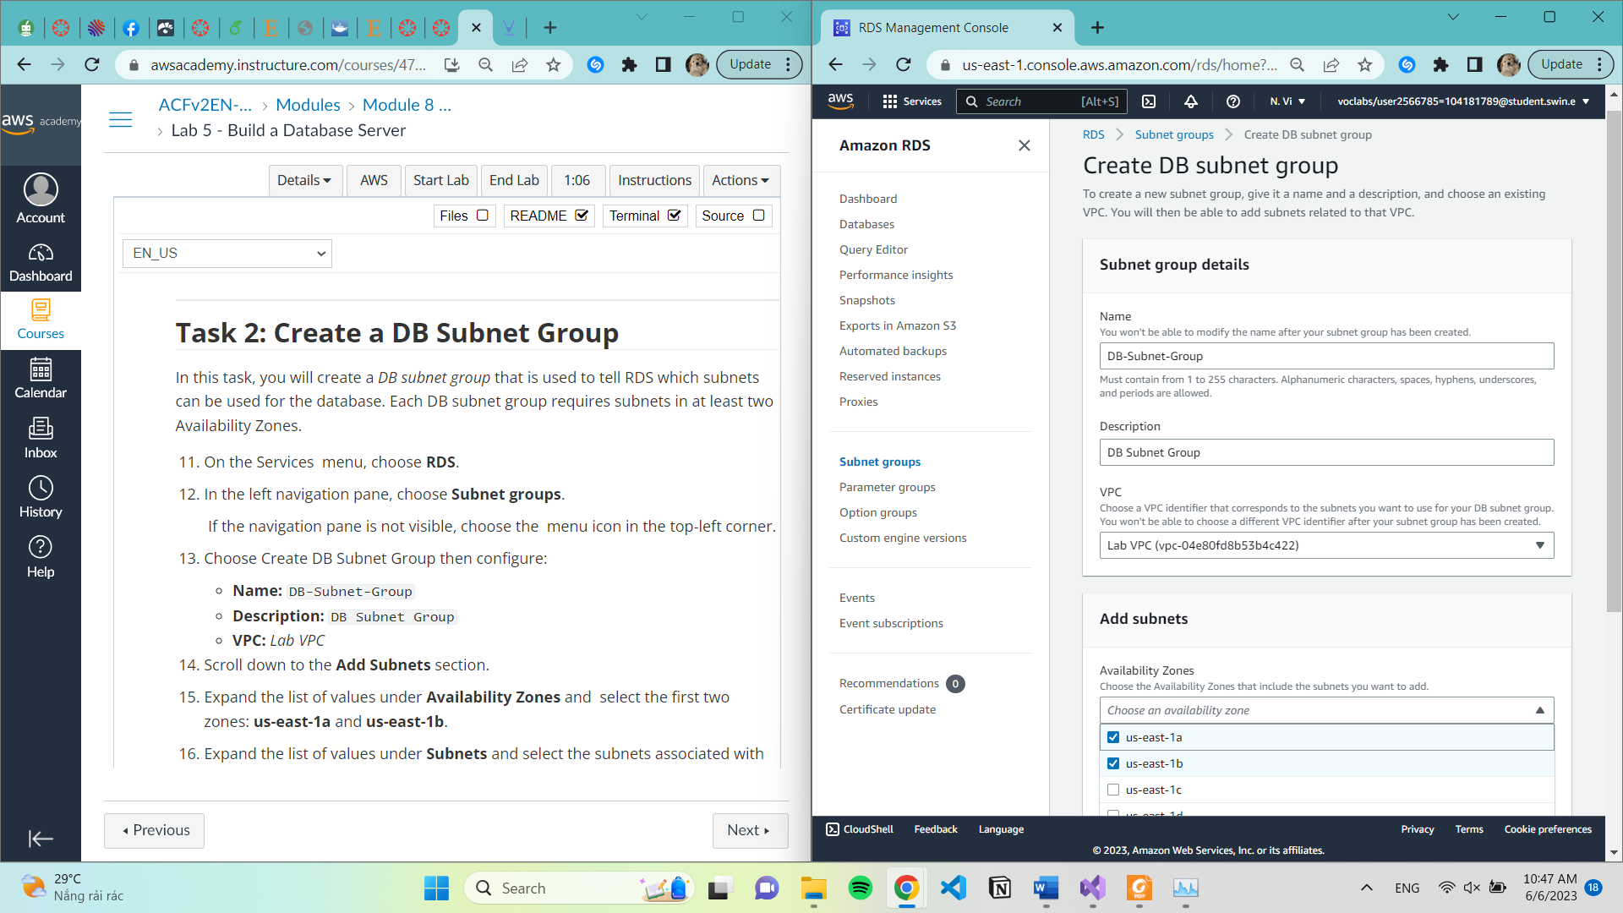

Expand the list of values under **Subnets** and select the subnets associated with the CIDR ranges **10.0.1.0/24** and **10.0.3.0/24.**

**Task 3: Create an Amazon RDS DB Instance**

choose **Databases** = > choose Create database

Select **MySQL** under **Engine Options**.

Under **Templates** choose **Dev/Test**.

Under **Availability and durability** choose **Multi-AZ DB instance.**

Under **Settings,** configure**:**

* **DB instance identifier:** lab-db
* **Master username:** main
* **Master password:** lab-password
* **Confirm password:** lab-password

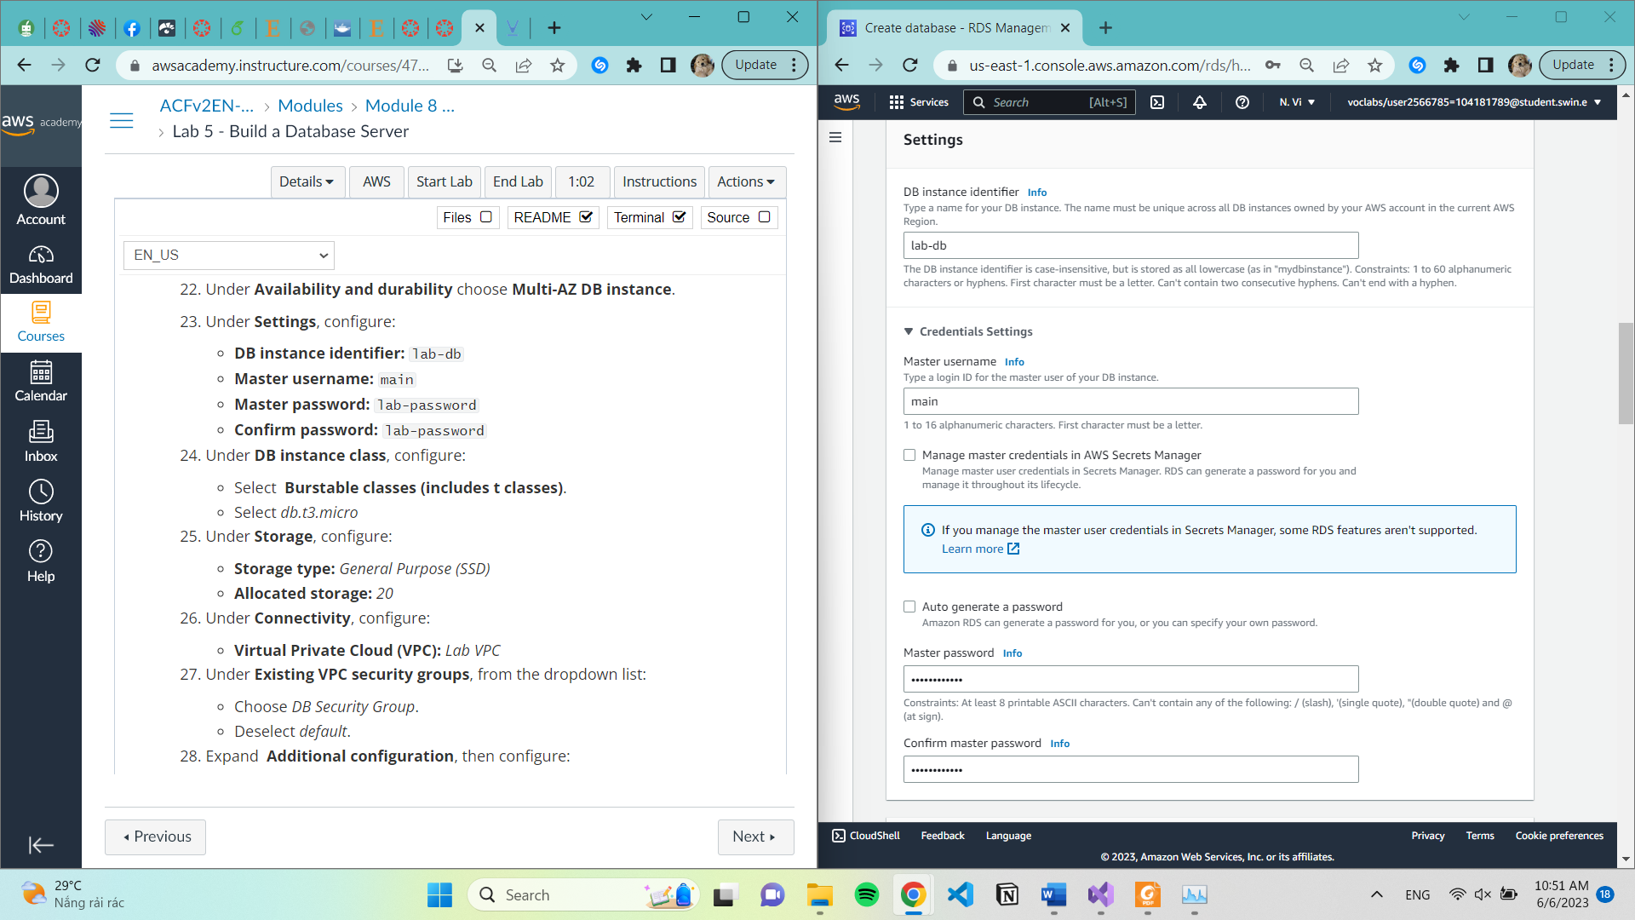

* Under **DB instance class,** configure**:**
* Select **Burstable classes (includes t classes).**
* Select **db.t3.micro**
* Under **Storage**,configure**:**
  + **Storage type:** General Purpose (SSD)
  + **Allocated storage:** 20

* Under **Connectivity**, configure:
* **Virtual Private Cloud (VPC):** Lab VPC
* Under **Existing VPC security groups**, from the dropdown list:
  + Choose DB Security Group.
  + Deselect default.

* Expand **Additional configuration,** then configure:
  + **Initial database name:** lab
  + Uncheck **Enable automatic backups**.
  + Uncheck **Enable encryption**
  + Uncheck **Enable Enhanced monitoring.**

* Choose **lab-db** then wait until **Info** changes to **Modifying** or **Available.**
* Scroll down to the **Connectivity & security** section and copy the **Endpoint** field.

**Task 4: Interact with Your Database**

**Choose the RDS link at the top of the page.**

* **Configure the following settings:**
  + **Endpoint**: Paste the Endpoint you copied to a text editor earlier
  + **Database**: lab
  + **Username**: main
  + **Password**: lab-password
  + Choose **Submit**

